**Apex & Pent**

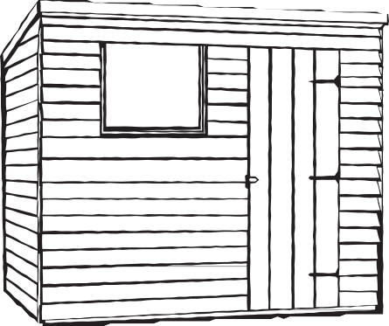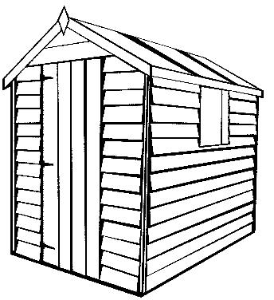

Width Depth

**Length Width**

|  |  |  |  |  |  |  |  |
| --- | --- | --- | --- | --- | --- | --- | --- |
| **Width/**  **Length** | **Shiplap**  **Self-assembly** | **Treat**  £35.00 |  | **Width/**  **Length** | **Shiplap**  **Self-assembly** |  | **Treat**  £40.00 |
| 4’x4’ | 495.00 | 5’x4’ | 581.00 |
| 4’x5’ | 575.00 | 5’x5’ | 661.00 |
| 4’x6’ | 655.00 | 5’x6’ | 741.00 |
| 4’x7 | 735.00 | Erect  £80.00 | 5’x7’ | 821.00 | **Erect**  £88.00 |
| 4’x8’ | 815.00 | 5’x8 | 901.00 |
| 4’x9’ | 895.00 | 5’x9’ | 981.00 |
| 4’x10’ | 975.00 | 5’x10’ | 1061.00 |

|  |  |  |  |  |  |  |  |
| --- | --- | --- | --- | --- | --- | --- | --- |
| **Width/**  **Length** | **Shiplap**  **Self-assembly** | **Treat**  £45.00 |  | **Width/**  **Length** | **Shiplap**  **Self-assembly** |  | **Treat**  £50.00 |
| 6’x4’ | 660.00 | 7’x4’ | 740.00 |
| 6’x5’ | 740.00 | 7’x5’ | 820.00 |
| 6’x6’ | 820.00 | 7’x6’ | 900.00 |
| 6’x7 | 900.00 | Erect  £90.00 | 7’x7’ | 980.00 | **Erect**  £95.00 |
| 6’x8’ | 980.00 | 7’x8 | 1060.00 |
| 6’x9’ | 1060.00 | 7’x9’ | 1140.00 |
| 6’x10’ | 1140.00 | 7’x10’ | 1220.00 |

|  |  |  |  |  |  |  |  |
| --- | --- | --- | --- | --- | --- | --- | --- |
| **Width/**  **Length** | **Shiplap**  **Self-assembly** | **Treat**  £55.00 |  |  |  |  |  |
| 8’x6’ | 1081.00 |  | |
| 8’x7’ | 1161.00 |
| 8’x8’ | 1241.00 |  |  |
| 8’x9’ | 1321.00 | **Erect**  £100.00 |  |  |  |
|  |  |  |  |
|  |  |  |  |
|  |  |  |  |

**The Following sheds come with 2 windows.**

**They will have truss’s if it’s an apex roof**

|  |  |  |  |
| --- | --- | --- | --- |
| **Width/**  **Length** | **Shiplap**  **Self-assembly** |  | **Treat**  £60.00 |
|  | |
|  | |
| 8’X10’ | 1446.00 |
| 8’X12’ | 1666.00 |  |
| 8’X14’ | 1886.00 | **Erect**  £150.00 |
| 8’x16’ | 2106.00 |
| 8’x18’ | 2326.00 |
|  |  |

**All apex & Pent prices Include:**

T&G Timber floor, Single door,

Green Mineral Felt, Temporary padlock, All fittings, instructions if self-assembly

**Apex & Pent optional extras:**

|  |  |
| --- | --- |
| Double door | £55 |
| Opening window | £46 |
| Fixed window | £25 |
| Polyester roofing felt | P.O.A |
| 20mmx 100mm plastic floor bearers | P.O.A |
|  |  |

**All Timber Construction- no sheet materials.**

**V.A.T. TO BE CHARGED AT CURRENT RATE.**

|  |  |
| --- | --- |
| **38 x 50 Framework** | **+7%** |
| **50 x 50 Pent roof (6’ & below)** | **+3%** |
| **47 x 70 framework** | **+15%** |
| **47 x 95 framework pent roof** | **+5%** |
| **T&G roof** | **8%** |
| **Pressure treated cladding** | **+12%** |
| **Stainless steel cladding nails** | **+8%** |
| **Polyester felt upgrade** | **£2.75pm** |
| **100mm taller** | **6%** |
| **Heavy shiplap upgrade** | **20%** |
| **Loglap upgrade** | **25%** |



# January ‘23

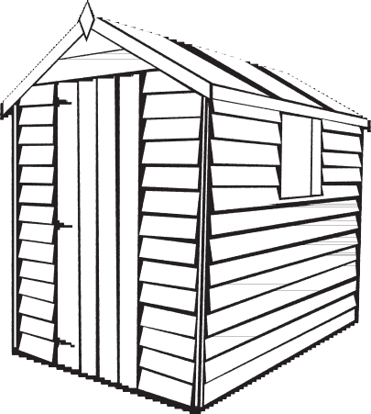**Apex & pent SHEDS**



T: 01243641683 E: sales@trojantimberproducts.co.uk

W: www.trojantimberproducts.co.uk

www.facebook.com/TrojanTimberProductsLtd



 www. twitter.com/TrojanTimber

 https://www.instagram.com/trojantimberproducts/